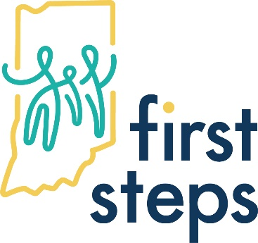
North East & North Central
Indiana First Steps
Meeting Minutes 2/7/23

Cluster B & Cluster C LPCC Child Find and Oversight Meeting Minutes
2/7/23 9:30 AM
In Attendance: Lily Osborn, Nancy Moore, Brigitte Leazenby, Clare Mann, Amy Ellis, Laura Guistolisi, Gwyndyn Seabolt, Holly Johnson, Jamie Burks, Noel Weibel, Jodi Curtis, Jenni Martine, Robyn Duffy, Shannon Berrisford, Amanda Cook, Paula Fox, Christy Shauver, Stephanie Furnas, Barbera Sanders, Angie Snyder, MaryEllen Schreck, Constance Young, Pam Dove, Holly Johnson, Justin Simus.

SPOE Report:
Reviewed referral summary for cluster B and C. High referral numbers for January 2023.
No specific numbers at this time. Marshall and Cass counties have had lower referrals.

Child Find Activities: Will update with LPCC this summer.

Fiscal Report:
Coordinator Salaries raised in December and will show on next Quarterly Report.
Cluster B: No new expenses at this time. Will end year well within budget.
20 full time employees. 1 new part time. 1 new employee as of September. 2 openings for service coordinator positions.
Assessment team: Scheduling 4 weeks out. Many are still virtual but this has been going well. No issues with filling spots with 2 assessment team members. Part time DT resigned that will need filled.
Cluster C: No new expenses at this time. Will end year well within budget.
25 total employees. 23 full time. 2 part time. Full staff. No new staff at this time.
Assessment team: Slow after holidays but now picking up. No resignations. Able to send 2 therapists out and filling spots quickly.

New Business and updates:
PNE has been able to bring on some new therapists and increase caseloads due to the pay raise.
Early Intervention Conference on June 8th. Reach out to Constance Young with questions.
Meeting concluded.
Upcoming LPP Oversight Meetings:
LPCC Oversight & Child Find Meetings:
Tuesday February 7th, 2023 at 9:30 am EST
Tuesday June 6th, 2023 at 9:30 am EST
Tuesday August 15th, 2023 at 9:30 am EST
Tuesday November 14th, 2023 at 9:30 am EST
Cluster C Transition Committee Meetings:
Tuesday February 14th, 2023 at 10:00 am EST
Tuesday September 19th, 2023 at 10:00 am EST
Cluster B Transition Committee Meetings:
Tuesday February 21st, 2023 at 10:00 am EST
Tuesday September 26th, 2023 at 10:00 am EST

All 2023 meetings will be held over zoom. Please double check dates as some meeting months have changed from previous years. Thank you!

